A000-Afr-Egy-Apis Bull-Bronze-Figurine-650 BCE



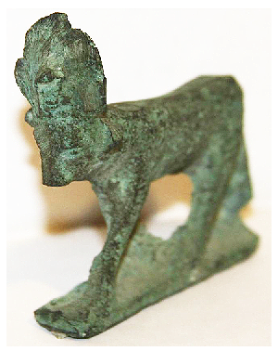



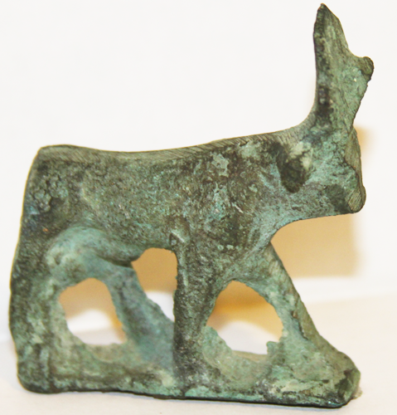

Fogs. 1-4. Afr-Egy-Apis Bull-Bronze-Figurine-650 BCE

Hathor bronze figurine, 2.5"W x 2.75"H

**Case No.: 2**

**Accession Number:**

**Formal Label:** Afr-Egy-Hathor as Cow Goddess--Bronze-Figurine-650 BCE

**Display Description:**

The bull called Apis in Greek was called ḥjpw, n Egyptian. Its existence precedes the First Dynasty (3150 - 2890 BCE) and so it is thought that Apis may be among the first animals associated with divinity.



In the First Dynasty it is known in the ceremony, “The Running of Apis.”

An Apis bull was selected based on a white triangle on the forehead and black spots resembling bird wings or scarabs on its flanks.

Apis iconography incorporated a sun disk between its horns, as here, the symbol of his mother, Hathor, and is one of few deities ever associated with her symbol.  The cow who was his mother was believed to have conceived him by a flash of lightning from the heavens and so he was conceived in a virgin birth, a concept which was taken over by the Council of Nicaea convened by the Roman Emperor Constantine I in 325 CE to substantiate Jesus of Nazareth’s divine origin. In this example the sun disk is incomplete but traces of it are between the horns.

The Apis bull participated in ceremonies of fertility and regeneration. When it died, it was embalmed and buried with all tributes, and a new Apis bull bearing the requisite markings was selected. Beginning with Amenhotep III (1390–1352 BCE, Dynasty 18), the locus of Apis burials gradually expanded. Ramesses II (1292–1190 BCE, Dynasty 19) initiated Apis burials in what now is known as the Serapeum, an underground complex of burial chambers at Saqqara for the sacred bulls, a site used into the reign of Cleopatra VII Philopator (69-30 BCE, r. 51-30 BCE).

**LC Classification:**

**Date or Time Horizon:**

**Geographical Area:**

**Map:**

**GPS Coordinates:**

**Cultural Affiliation:**

**Medium:** bronze

**Dimensions**: H 2.75 in; W 2.5 in  
**Weight: histrian** *traveler from a historic section of West Hartford CT. Many of the antiques were acquired during a lifetime of global travel and collecting.*

**Condition:** original.

**Discussion:**

**References:**

Brunet, J.-F. 2005. The XXIInd and XXVth Dynasties Apis Burial Conundrum, in: Journal of the Ancient Chronology Forum 10, 26-34.

Ibrahim, M., D. Rohl. 1988. Apis and the Serapeum, in: Journal of the Ancient Chronology Forum 2 (JACF), 6-26.

Smith, Mark. 2017. Following Osiris: Perspectives on the Osirian Afterlife from Four Millennia. Oxford: Oxford University Press, 2017.

Thompson, Dorothy J. .2012. Memphis Under the Ptolemies, Second Edition. Princeton, 2012.

Vandier, Jacques. 1961. Memphis et le taureau Apis dans le papyrus Jumilhac (in French), in: Jean Sainte Faire Garnot (ed), Mélanges Mariette. Cairo.

Vercoutter, Jean. 1980. The Napatan Kings and Apis Worship, in: KUSH 8, 62-76.

Vos, R. L. 1992. The Apis Embalming Ritual: P. Vindob. 3873. Leuven.